*** 這次問卷調查我們一共收到87份回覆。我們感謝所有參與的教友。以下是這份問卷調查的結果簡報。We appreciate having received 87 responses on our CCCM COVID-19 Survey and below is the summary report of the results. ***

團體網上彌撒 Community Online Mass
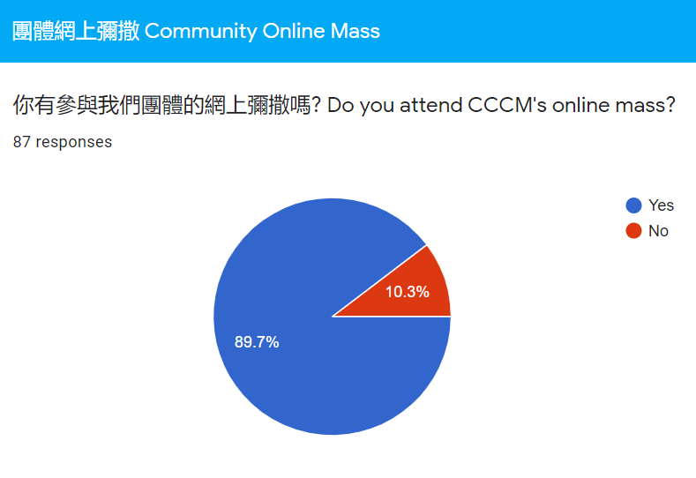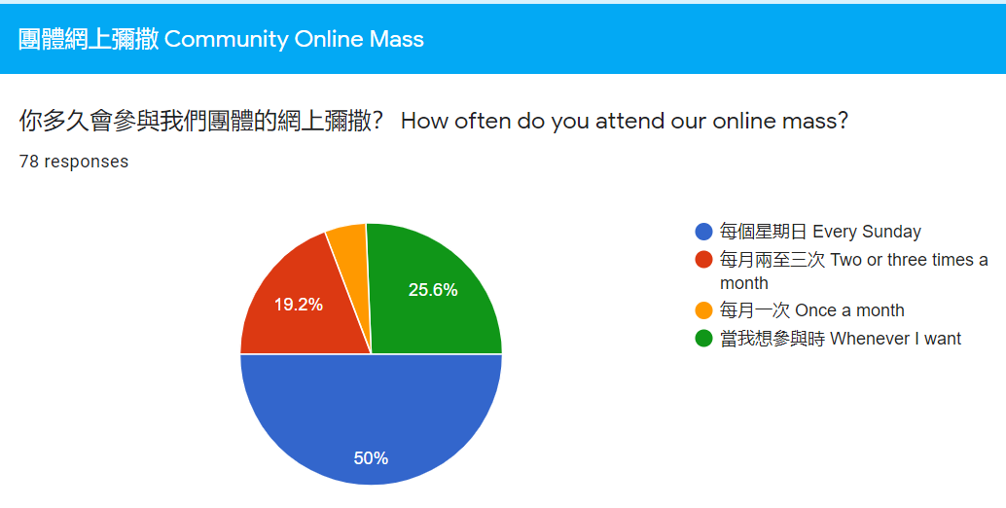
以下是一些我們收集到教友提出有關於網上彌撒的意見並已經跟進的 We have already taken actions on the following suggestions:
- 有關登入方式 About logging in：
  - 希望每星期Zoom mass with the same ID and same password
  - sending the Zoom link earlier and committee is more prepared to avoid last minute technical difficulties; 早些開link使我們早有準備
- 有關禮儀 About Liturgy ：
  - 能夠看到祭台更好
  - Involve more members to participate in mass e.g. readers
  - 神領聖體經的默想時間可以長一點
  - father's voice is a bit soft
  - It would be good to have one part of the readings in English e.g. the second reading
- 有關歌詠部分 About Choir：
  - 可展示聖詠歌詞; Show the lyrics;
  - 能夠有更好嘅方式去參與唱歌
- 其他建議 Others：
  - The message regarding donation should be included in every online mass [Rolling video, last slide]
  - better way to deliver announcements
以下是一些我們收集到教友提出有關於網上彌撒的意見並會研究改善的 Following are the suggestions about our online Mass which we will review and try to improve on:
- 聖詠唱得好聽,讀經等有經文同時看到，我意見如果福音有更好。
- 覺得彌撒前最好有些靜修音樂讓教友收拾心情去祈禱
- Homilies that are more relatable and have more depth. I understand God is love and we should rely on God, but how do we live out our faith every day?
- More impactful homilies

至於如果維省政府准許最多20人參與彌撒，團體多數回應是不會參與, 故此, 我們決定我們將不會安排20人的現場彌撒. In regarding to, if Victorian Government allows up to 20 people to attend a mass, according to responses received, CCCM decided it is not practical to hold Mass with 20 attendants.

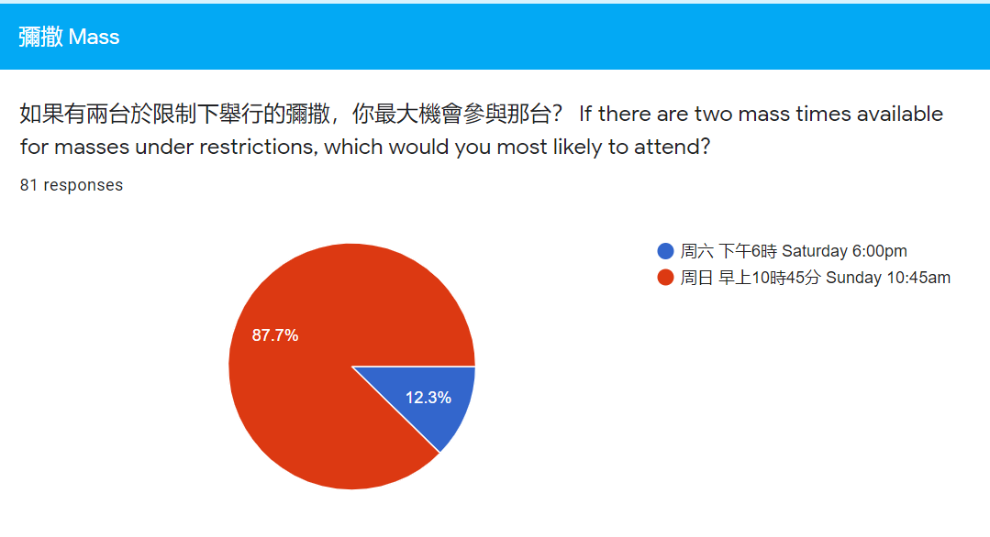
- 大部分回應都是傾向參與周日彌撒和網上彌撒. Preferred attending mass on Zoom or in church on Sunday, not Saturday.

支援和交流 Support and Communication

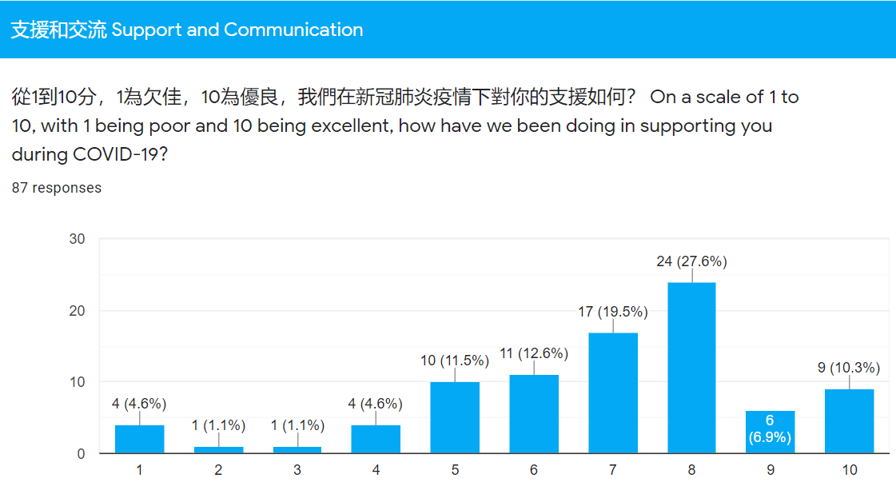
以下是一些我們收集到教友提出有關於支援的意見並會研究改善的 Following are the suggestions about our support and communication which we will review and try to improve on:
- Feeling isolated and not connected to our community
- Publishing CCC news and religious articles via post to parishioners
- 如果團體可以安排網上活動可讓年幼子女參與或主日學網上上課。因感到小孩在這段疫情期間信仰上得不到太多進步
- 其他有關活動建議 Other activities suggestions:
  - cooking lesson
  - ZOOM的祈禱會
  - trivia
  - children's activities
  - 心靈改變的教導及朝拜聖體
  - Online game
  - Online bible stories sharing for kids
  - Health & exercises talk
  - 信仰學習或講座
  - Photo competition
  - face mask making class

總結收集到的意見，團體委員會會研究並討論在疫情過後，如何能夠在以下５方面作出支援 Based on the responses received, CCCM will review and discuss on how to provide the following 5 aspects of support to our community when restrictions ease off：
- 網頁更新Website update
- 恢復正常活動Resume normal activities
- 網上彌撒YouTube Mass
- 疫後安全計劃COVID Safe Plan
- 家庭探訪Home Visit

田神父與我們 Fr James and Us
我們已經把有關田神父的意見轉交神父考慮和安排，並綜合成以下８方面 We have forwarded all the Fr James’ related suggestions to him for his consideration and have generated to the following 8 categories：
- 信仰講座Faith Talk
- 聖經講座Bible Talk
- 五年計劃5-years Plan
- 團體未來方向CCCM direction
- 如何實質地活出信仰How to live out our Faith more practically
- 如何屬靈地與小組連繫Connection with teams spiritually
- 聖人Saints
- 避靜Retreat

2020 團體周年大會 AGM
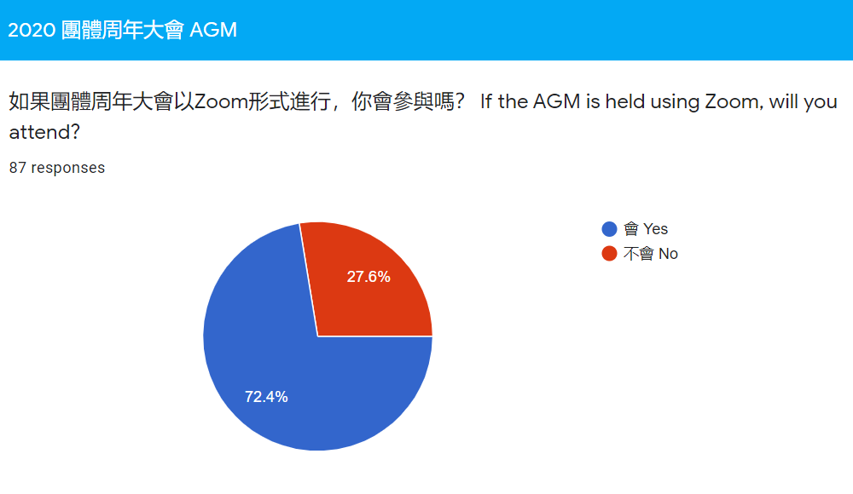
基於維省現階段的封閉措施，並根據以上教友的回應結果，團體委員會決定今年的周年大會會以網上Zoom形式進行。詳情將會稍後公布。Due to the current COVID-19 restrictions in Victoria and our majority responses about AGM, CCCM EXCO decided that we will hold our 2020 AGM using Zoom. Details will be announced in the near future.

通訊與科技使用 Communication and Use of Technology
